A YAML file is used to represent the configuration data. Below is the quick comparison among XML, JSON and YAML.

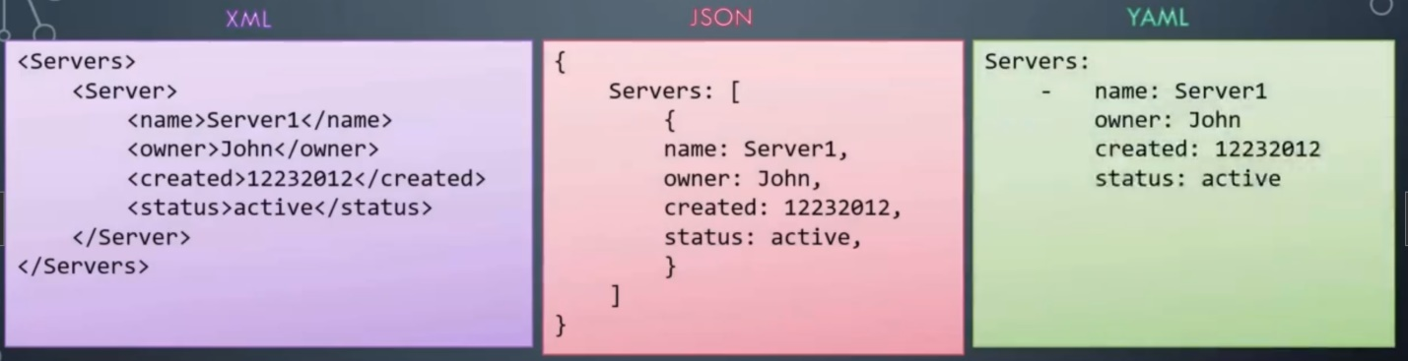

In its simplest form, below is the way of defining data in YAML using Key-Value pair. The separator is colon (:)

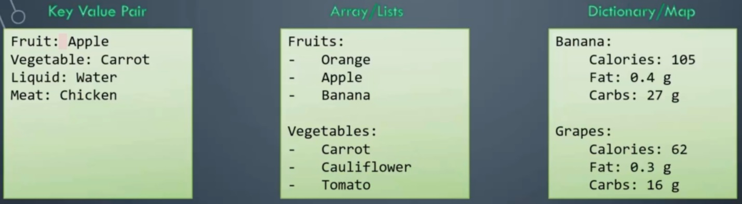

You must have equal number of blank spaces before the properties of a single item. So, they are all aligned together.

**YAML Advanced**

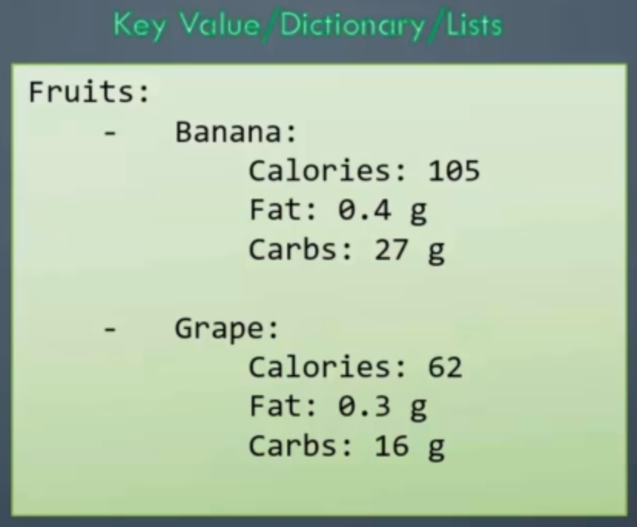

In this case, we have a list of Fruits and the elements of the list are Banana and Grape. But each of these elements are further dictionaries containing nutrition information.

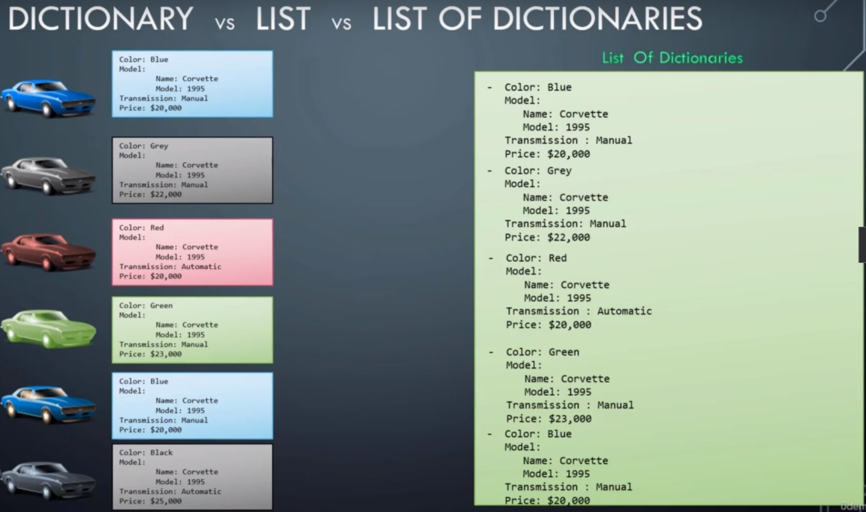

**YAML Notes**

